**Week 4 Module 6.3 Assignment**

Juan Macias Vasquez

Bellevue University

CSD340-H323 Web Development with HTML and CSS (2261-DD)

**Adam Bailey**

September 6th, 2025

**Module 6.3 BioSite**

**bioSite: Development**

**GitHub Repository Link**

<https://github.com/Juan551School/bioSite>

**Chosen Person**

My Sister Jasmine Macias Vasquez

Module 6.3 Assignment

**Updated Biography/Interview (Still not Final)**

Jasmine was born in June 25th, 2003 She grew up with her parents, an older brother, and a younger sister most of her life in Colorado with living a few months in Wyoming because of her father’s work. She had also spent a little bit of time in Massachusetts for her four years of university but still always went back to Colorado even if it was just for a small amount of time like spring break that lasted a week.

Jasmine Went to Boston College to study becoming a nurse practitioner. She chose this school due to the full ride scholarship she got even though it was far from home and she would feel home sick every now and then. The first school she went to was out of state in Massachusetts but is now studying at a Redrock’s community college to do some credits before transferring to another University to complete the master’s degree.

Her first pet was a cute half Poodle half Maltese dog named princess who she loved dearly but sadly passed away in summer of 2020. Her current pet is a cat she got as a cute kitten from her friend named Ivy. At first, she thought he was a girl when she got him which is why she named him Ivy.

I always helping at home like taking her younger sister Amy to school and making sure she isn’t late to her college prep courses. Jasmine really Liked Hello Kitty and other cute things, building Legos, doing crafts in her free time, and going to the gym to weightlift and run on the treadmill. Her whole room is decorated in art and crafts or pictures of her with her friend, or her with her sister who she loves spending time with and helping her whenever she needs it.

**Picture of new repository for BioSite**

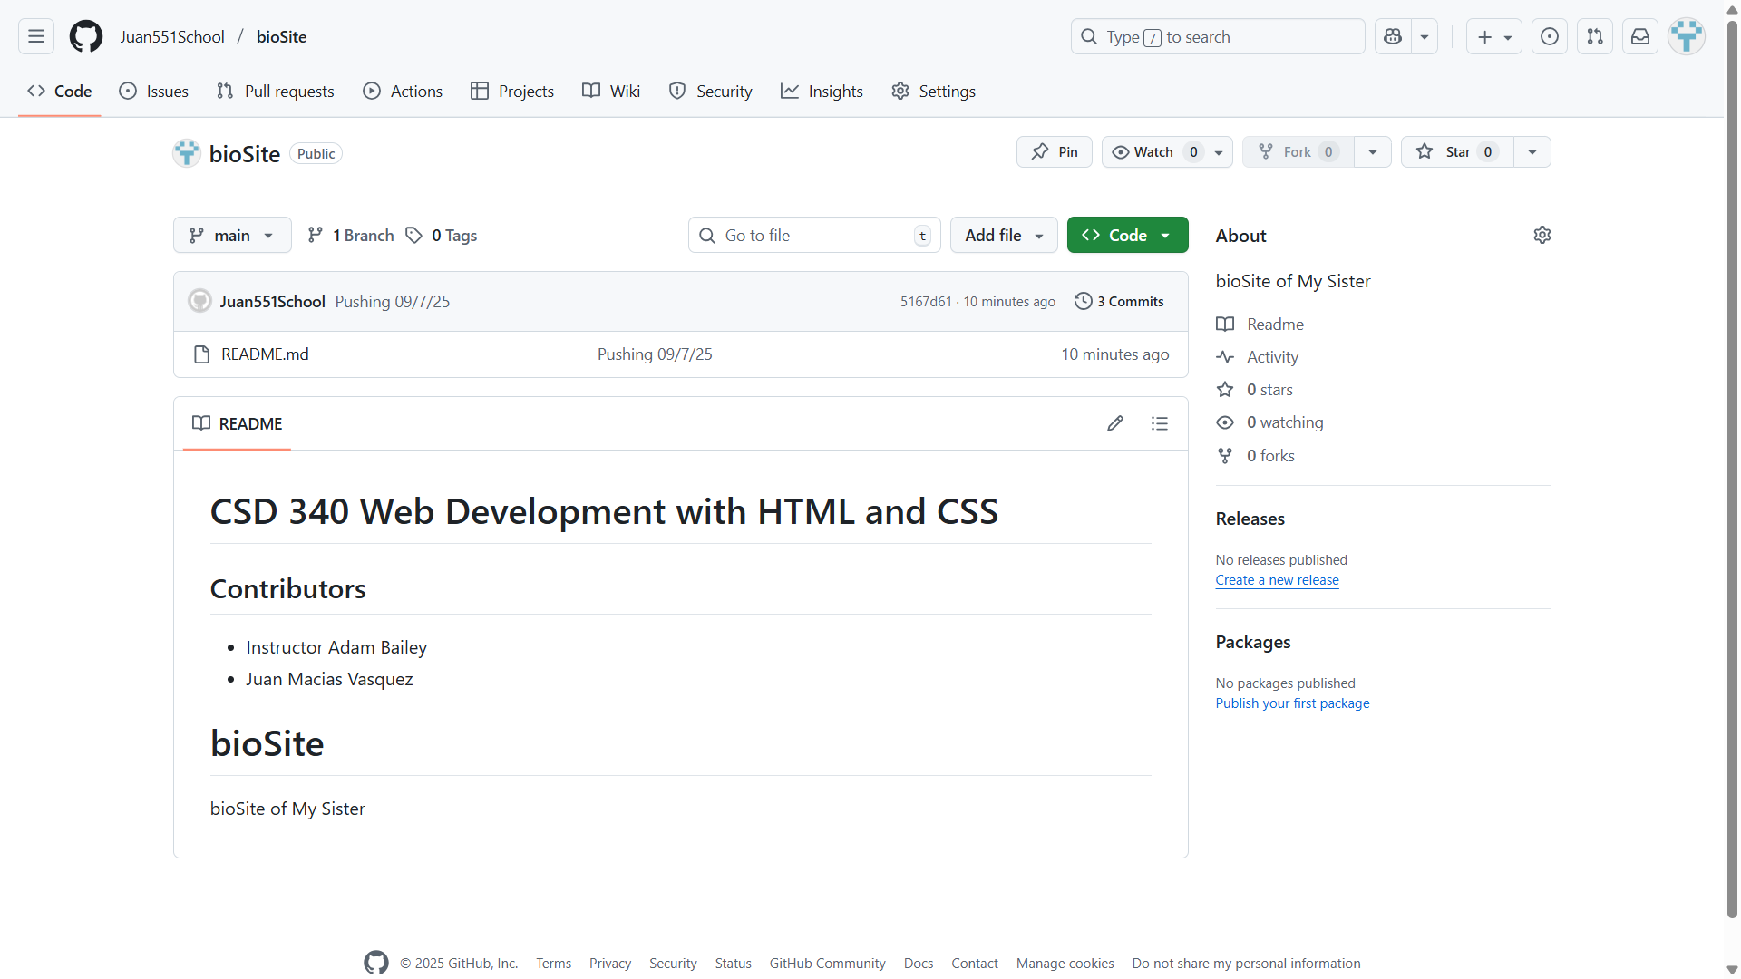

**Pictures of Webpages so Far (Still in early development) (She wanted it more pink)**

**Landing Page**

Need to make graduation picture smaller so that it isn’t so long compared to the others.

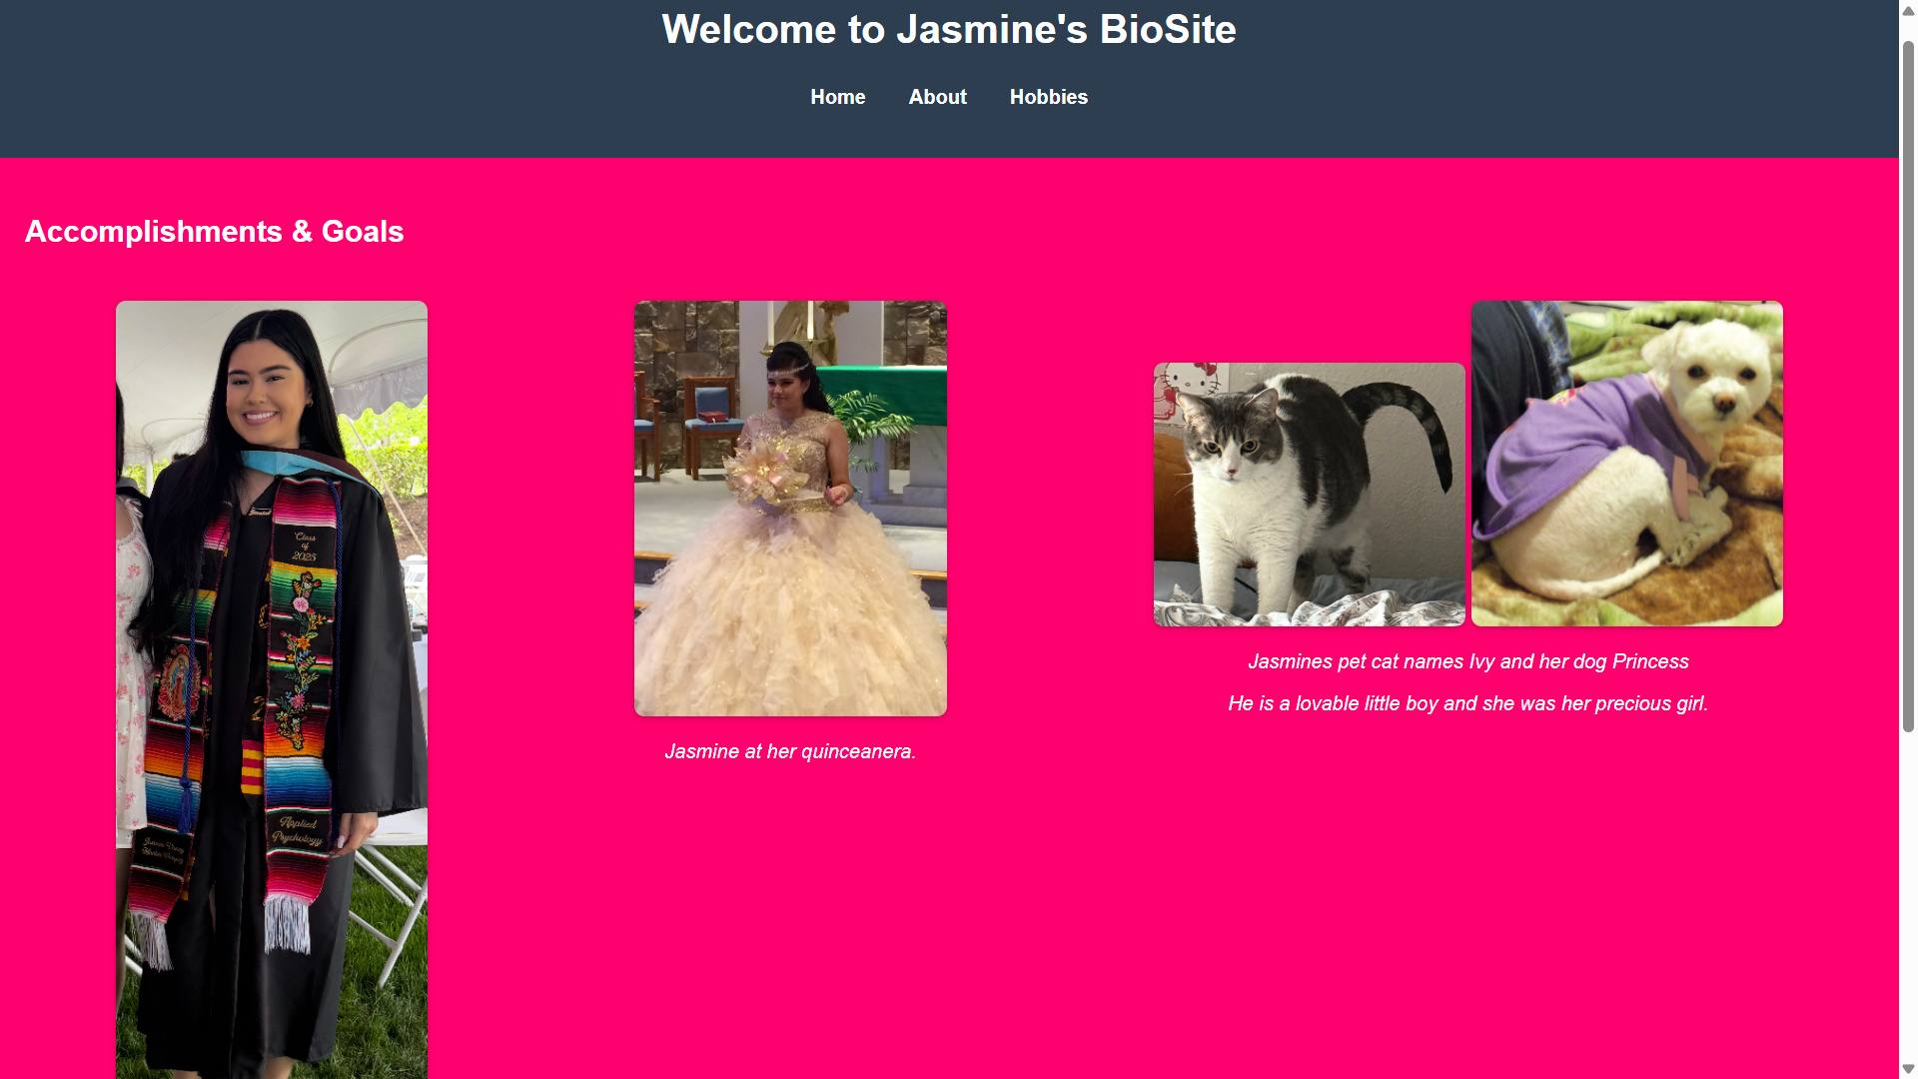

**About Page**

Still haven’t added the whole Biography just testing how to make it fit better

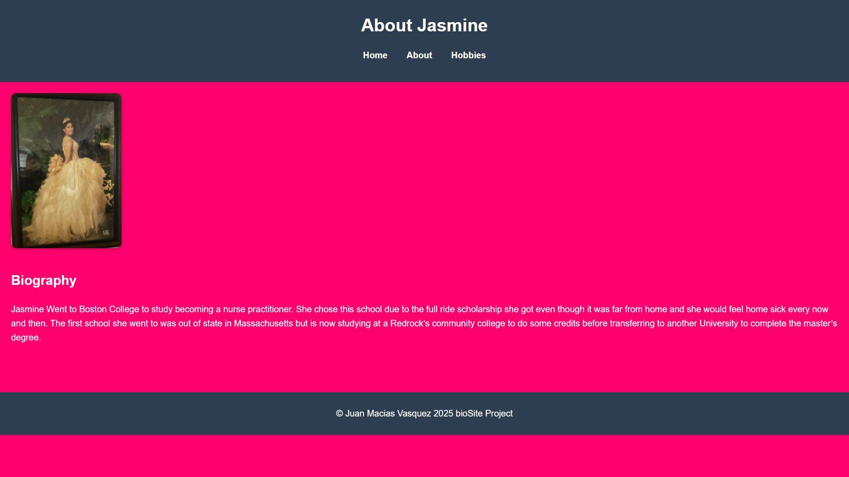

**Hobbies page**

Still need to take pictures of her doing her hobbies

